Assignment 2

Name: G.Ashrita

Reg.No:21BCE8697

output:
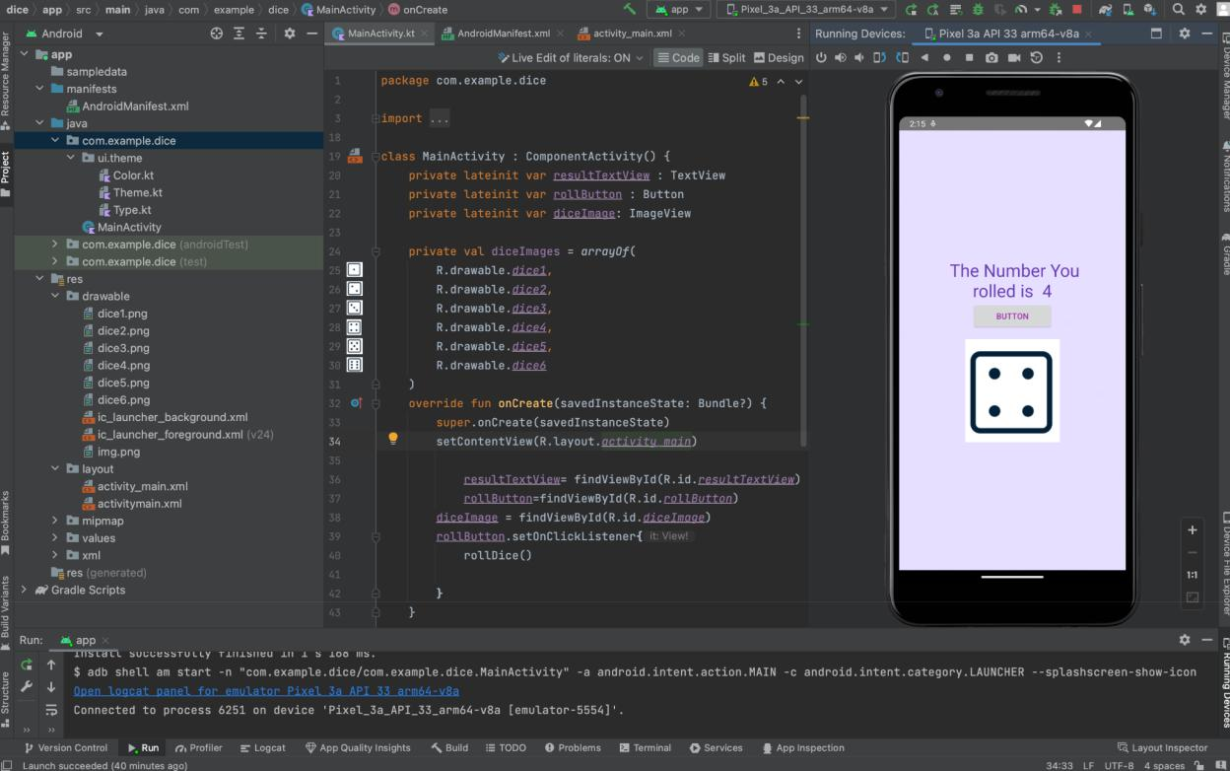
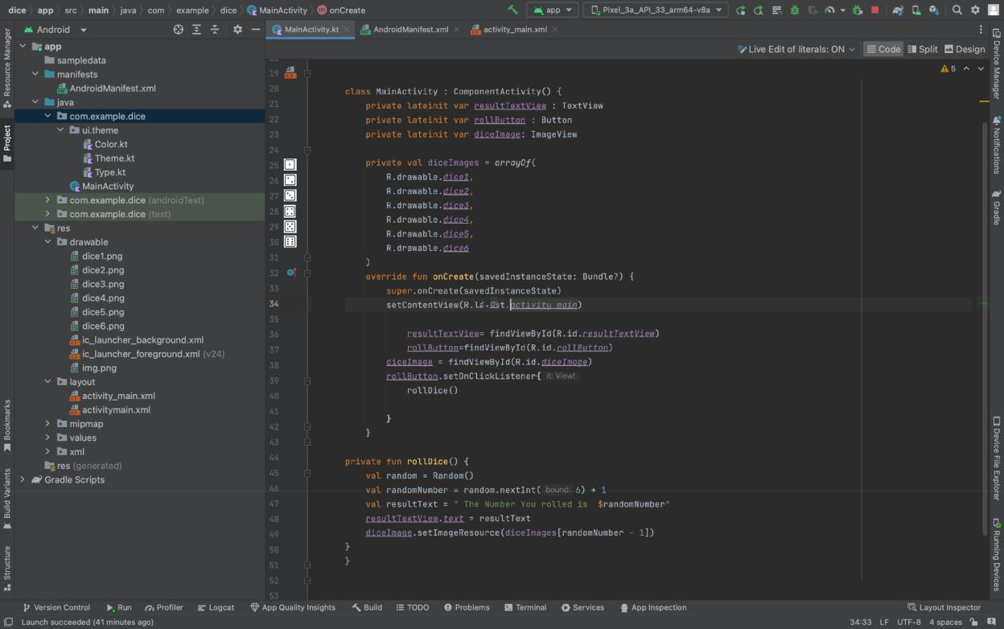

Zip file link:

https://drive.google.com/drive/folders/1AtD

tW530qh_cR5Xev3_YYvRHlHZ4mCvG?usp=sh

aring

